irrigationglobal.com Irrigation systems design questionnaire
Dear potential customer, thank you for contacting irrigationglobal.com
In order to offer you a professional and reliable consultancy and design, we would like to receive all the relevant data concerning your project.
Please complete the questionnaire and attach the following items:
 |  | - Map or layout, illustrating the field dimensions, topography, water sources, roads, buildings, etc. If possible, please attach photographs. we read and analyze the following file formats: PDF, Tiff, DWG, DXF.  - Or a Google KMLor KMZ files http://code.google.com/apis/kml/documentation/kml_tut.html  - Please include the water source / Pumping station detailed on the map.  - Also, if possible marc the row direction per each crop lot.
 |  | Soil & Water analysis
 |  | A Pump test or details including drawings and photos of the water source intake place.
Name and Job Title
Company
Address & country
Email
Tel
Crops to be irrigated
Desired irrigation method  Type of irrigation method you are interested in? |  |  |  |  |  | Drip irrigation  Mini sprinklers  Midi sprinklers | Mist sprayers  Jet sprayers  Sprinklers
Size of area to be irrigated
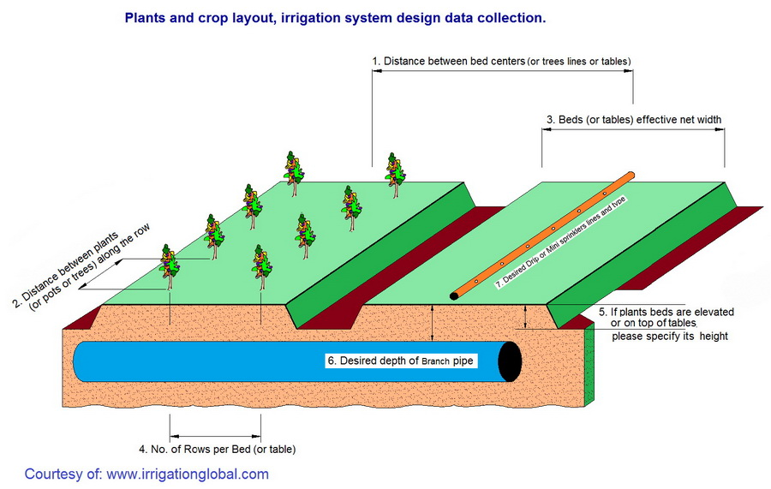
1. Distance between bed centers (or tree lines or tables)
2. Distance between plants (or pots or trees) along the row
3. Beds (or tables) effective net width
4. Number of rows per bed (or table)
5. If plants beds are elevated or on tables, please specify height
6. Desired depth of branch pipe
7. Desired type Drip line or Mini sprinklers

Maximum daily water consumption of the crop/tree/pot
Daily temperatures |  |  | Maximum |  |  |  | Minimum
Maximum daily evaporation
Type of soil? (Soil definition) |  |  |  |  |  |  |  |  |  |  | Soil type |  |  | Particles  ∅ (mm)
 |  |  |  |  |  |  |  |  |  |  | Clay |  |  | less than  0.002
 |  |  |  |  |  |  |  |  |  |  | Silt |  |  | 0.002–0.05
 |  |  |  |  |  |  |  |  |  |  | Very fine sand |  |  | 0.05–0.10
 |  |  |  |  |  |  |  |  |  |  | Fine sand |  |  | 0.10–0.25
 |  |  |  |  |  |  |  |  |  |  | Medium sand |  |  | 0.25–0.50
 |  |  |  |  |  |  |  |  |  |  | Coarse sand |  |  | 0.50–1.00
 |  |  |  |  |  |  |  |  |  |  | Very coarse sand |  |  | 1.00–2.00
Water source (type & capacity) |  |  |  |  |  |  |  |  |  |  |  |  | River  Pool  Lake  Well  Canal
Existing pump?
Flow rate & pressure
Required irrigation automation? |  |  |  |  |  |  |  |  |  |  |  |  | Auto-metering valve  timer controlled system  volume controlled system
Required fertilization |  |  |  |  |  |  |  |  |  |  |  |  | Fertilizers pump  Pressure Tank
maximum available weekly days for irrigation
maximum available hours per day for irrigation
Other comments

Please return the form and the attached files to: service@irrigationglobal.com
Irrigation planning form. Irrigation design form.

